Sensory Processing Disorder
By: Kayla Matkowski, Tamara Dennis, Kristin Kobbert, and Kennedy Carpenter

1. Define the Exceptionality:
- What is SPD?
  - “a [neurological] condition that exists when sensory signals don't get organized into appropriate responses. Pioneering occupational therapist and neuroscientist A. Jean Ayres, PhD, likened SPD to a neurological "traffic jam" that prevents certain parts of the brain from receiving the information needed to interpret sensory information correctly.”
  - Children with sensory processing disorder have difficulty processing information from the senses (touch, movement, smell, taste, vision, and hearing) and responding appropriately to that information. These children typically have one or more senses that either over- or underreact to stimulation. Sensory processing disorder can cause problems with a child's development and behaviour.
  - One study (Ahn, Miller, Milberger, McIntosh, 2004) shows that at least 1 in 20 children’s daily life is affected by SPD. Another research study by the Sensory Processing Disorder Scientific Work Group (Ben-Sasson, Carter, Briggs-Gowen, 2009) suggests that 1 in every 6 children experiences sensory symptoms that may be significant enough to affect aspects of everyday life functions.
  - “misdiagnosis is common because many health care professionals are not trained to recognize sensory issues”
    - Common misdiagnosis is ADHD

- What are the causes?
  - coded into genetic material, they are born with it
    - premature birth, brain injury
  - Anyone can have SPD!
    - can be alone or can be comorbid
    - SPD with other common childhood disorders such as ADHD, autistic spectrum disorders including Asperger's, Fragile X Syndrome, Prader-Willi Syndrome, and many other diagnoses.
    - SPD and Autism/ADHD→ “children with autistic spectrum disorders have significant symptoms of Sensory Processing Disorder. However, the reverse is not true. Most children with SPD do not have an autistic spectrum disorder!”
  - The exact cause of sensory processing disorder is not known. It is commonly seen in people with autism, Asperger's syndrome, and other developmental disabilities. Most research suggests that people with autism have irregular brain function. More study is needed to determine the cause of these irregularities, but current research indicates they may be inherited.
- How is SDP diagnosed?
  - A health professional, often an occupational or physiotherapist, will evaluate your child by observing his or her responses to sensory stimulation, posture, balance, coordination, and eye movements.
    - While many children have a few of the symptoms described above, your health professional will look for a pattern of behaviour when diagnosing sensory processing disorder.
- SPD Codes:
  - HEARING DISABILITY (ECS: Code 30; Grades 1–12: Code 55)
  - VISUAL DISABILITY (ECS: Code 30; Grades 1–12: Code 56)
    - Special Education Coding Criteria 2010/2011 (http://www.ldalberta.ca/wp-content/uploads/2010/10/TeachersResource_SpEdCoding2010and2011.pdf)

- Case Study: A Child’s View of SPD: https://www.youtube.com/watch?v=D1G5ssZlVUw

- Types of sensory input include:
  - Visual or vision input: What you see
  - Auditory or sound input: What you hear
  - Tactile or touch input: What you feel through touching, or through your skin, etc.
  - Olfactory input : What you smell
  - Gustatory input: What you taste, such as when you eat or drink
  - Vestibular or movement input: What you feel when you are moving, such as your arms, legs or your body
    - These senses all work together to allow us to carry on our daily activities. It becomes so automatic, that we don't even think about it, but we are processing sensory input every single moment.

Resources:
- SPD Foundation: http://www.spdfoundation.net/about-sensory-processing-disorder/
- eMentalHealth:http://www.ementalhealth.ca/Alberta/Sensory-Processing-Problems/index.php?m=article&ID=8890
- Myhealthalberta: https://myhealth.alberta.ca/Health/pages/conditions.aspx?hwid=te7831&
- Sensational Kids: http://sensationalkidsot.com.au/home/sensory-processing/

2. Identify Characteristics and Observable Behaviours:

- SPD characteristics and observable behaviours:
  - Children with Sensory Processing Disorder often have problems with motor skills and other abilities needed for school success and childhood accomplishments. As a result, they often become socially isolated and suffer from low self-esteem and other social/emotional issues.
  - Many emotional, social, and educational problems, including the inability to make friends or be a part of a group, poor self-concept, academic failure, and being labeled clumsy, uncooperative, belligerent, disruptive, or "out of control." Anxiety, depression, aggression, or other behavior problems can follow. Parents may be blamed for their children's behavior by people who are unaware of the child's "hidden handicap."
  - Children with sensory processing disorder cannot properly process sensory stimulation from the outside world. Your child may:
    - Either be in constant motion or fatigue easily or go back and forth between the two.
    - Withdraw when touched.
    - Refuse to eat certain foods because of how the foods feel when chewed.
    - Be over sensitive to odours.
    - Be hypersensitive to certain fabrics and only wear clothes that are soft or that they find pleasing.
    - Dislike getting his or her hands dirty.
    - Be uncomfortable with some movements, such as swinging, sliding, or going down ramps or other inclines. Your young child may have trouble learning to climb, go down stairs, or ride an escalator.
    - Have difficulty calming himself or herself after exercise or after becoming upset.
    - Jump, swing, and spin excessively.
    - Appear clumsy, trip easily, or have poor balance.
    - Have odd posture.
    - Have difficulty handling small objects such as buttons or snaps.
    - Be overly sensitive to sound. Vacuum cleaners, lawn mowers, hair dryers, leaf blowers, or sirens may be upsetting.
    - Lack creativity and variety in play. For instance, your child may play with the same toys in the same manner over and over or prefer only to watch TV or videos
  - Chances are, a child with sensory issues will be the one in a group not following your instructions, acting hyper, over-anxious, extra loud, or just giving the sense that he’s “off.”
- 3 Main Types of SPD:
  - Sensory Modulation Disorder (SMD):
    - The child experiences difficulty processing sensory information into appropriate behaviours/responses which match the intensity of the sensory information (Miller, 2006)
    - There are 3 types of SMD:
      - I. Sensory Over-Responsivity (sensory defensiveness) This is where children respond more intensely & faster for longer durations e.g. becoming really upset when touched by another child standing in line (Miller, 2006)
      - II. Sensory Under-Responsivity – These children show less of a response to sensory input than would be expected for the situation, they take longer to respond and require more intense input before they even respond e.g. having a high pain threshold (Miller, 2006)
      - III. Sensory Seeking – These children have a intense craving for sensory experiences and will actively seek this out, often in ways that aren’t matched or appropriate to the environment e.g. running around during group time (Miller, 2006)
  - Sensory-Based Motor Disorder (SBMD):
    - This is where the child has trouble controlling, planning and supporting their movements into a smooth, coordinated and sequenced way.
    - There are 2 types of SBMD:
      - I. Dyspraxia – These children have difficulty processing sensory information to create physical, unfamiliar or sequenced movements e.g. difficulty riding a bike (Miller, 2006)
      - II. Postural Disorder – These children have difficulty maintaining enough control of their bodies to meet the demands of a given motor task e.g. difficulty remaining in an upright sitting position for writing tasks (Miller, 2006)
  - Sensory Discrimination Disorder:
    - This is where the child experiences difficulty distinguishing between similar sensations. They need additional time to process sensory information and their capacity to perceive the information as quickly and naturally as other children do is reduced. For example they may unable to up their buttons or find their pencil in their pencil case without looking (Miller, 2006)
  - http://sensationalkidsot.com.au/home/sensory-processing/

- Types of sensitivities:
  - 1) Sensory Defensiveness (Over-Responsive): These are kids whose nervous systems feel sensation easily or intensely and they become overwhelmed from too much sensory information. For these children, things feel too loud, too fast, or too bright.
  - Different types of sensory sensitivities include:
    - Touch / tactile hypersensitivity: Easily overwhelmed with touch input, such as tags on clothing or food textures that are either too mushy or too crunchy, leading to being a picky eater.
    - Visual hypersensitivity: Easily over-stimulated by visual input, such as fluorescent or bright lighting or environments with a lot of visual input, such as classrooms, malls and fairs.
    - Vestibular hypersensitivity: (things tend to get "too fast"): Tends to feel movement too intensely and thus may easily feel car sick or be afraid of activities where one's feet leave the ground, and dislike ladders or amusement park rides.
    - Auditory hypersensitivity: Gets easily upset by noise created by home appliances, lawn mowers or school buses or noise occurring within a classroom or school assembly setting. Individuals who are hypersensitive to sounds may sometimes create noise (e.g. making their own noises or making white noise) in an attempt to drown out other distressing noises. *(more on Auditory Sensory Disorder - http://www.asha.org/public/hearing/Understanding-Auditory-Processing-Disorders-in-Children/)
    - Fight, Flight or Freeze Response: When a child is overwhelmed by sensory input their responses may include:
      - Fight - anger, irritability, tantrums or explosive rages.
      - Flight - panic, running away or withdrawal.
      - Freeze - where a child is so overwhelmed that the child simply is unable to speak or move.

- 2. Sensory-Seeking Children: These are children whose nervous systems crave more sensory input, and they may seem almost like they have an insatiable desire for sensory stimulation. For example, they may seek out movement stimulation rocking on their chairs. They may seek out oral motor stimulation by chewing on their shirts. Those who are unable to meet their own sensory needs may complain of ‘being bored'.
- 3. Sensory Under-Responsive Children: Sensory Under-Responsive kids appear sedentary and passive. They do not actively seek out sensory stimulation and may appear lethargic and unmotivated when completing their daily activities. These children may need significantly increased sensory input in order to register the information. For example, having the child take part in a body break before sitting to learn and hands on learning.
  - Poor Motor Coordination
    - Due to difficulties processing sensory information, many children with sensory processing issues may present as clumsy and awkward in their day to day life. For example, the child who has a weak grasp because his tactile system under registers the information. Other examples would be difficulties with stairs, bicycle riding and skating.

Resources:
- MyHealth.Alberta.ca: https://myhealth.alberta.ca/Health/pages/conditions.aspx?hwid=te7831&
- Sensory and More: http://sensoryandmore.com/sensory-processing-disorder-what-is-it/what-does-sensory-processing-disorder-feel-like/
- SPD Foundation: http://www.spdfoundation.net/about-sensory-processing-disorder/
- eMentalHealth: http://www.ementalhealth.ca/Alberta/Sensory-Processing-Problems/index.php?m=article&ID=8890

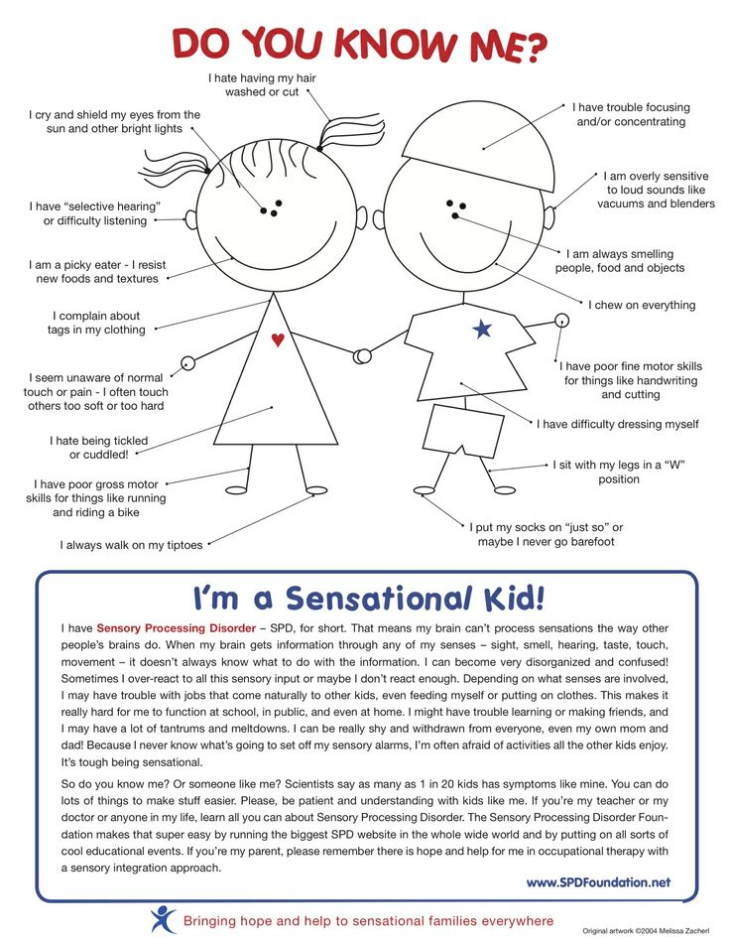
3. Effective Teaching Resources and Strategies:

- Turning Therapy into Play:
  - Play Doh, Gak, Glop, Funny Foam, etc…
    - Children need to touch a variety of textures and play with them to develop normal tactile processing. If your child will not play with messy items, it is even more important that you continue to find fun and creative ways to introduce these to them.
    - You could use Play Doh while spelling sight words, learning the Alphabet, etc.
  - Heavy Work Activities:
    - These types of activities are imperative for children who have difficulty regulating their arousal levels. They are the crashers, the jumpers, the leg shakers, the ones that can't ever seem to sit still. Regular heavy input into their neurological systems WILL help calm them down. The premise behind these activities is to help their bodies receive regular input into their muscles and joints in the most appropriate ways so they can get the input they crave and settle their bodies down. You will see and hear a lot about heavy work activities.
    - In your classroom you can include activities such as:
      - weights, weighted products, jumping, bouncing, rocking, pushing, pulling, swinging and being "squished"
  - Sleep Programs / Products
    - Use these techniques in your classroom to create a calming and relaxing environment for the child:
      - nature sound machines
      - white noise machines
      - aromatherapy machines
      - bubble tubes, rope lights, lava lamps etc.
      - relaxation cd's
      - weighted blankets
      - heavy work activities prior to bed
      - vibrating mattresses and vibrating pillows
      - unique children's sleeping bags
  - Sand And Water Play:
    - Playing in the sand or water provides essential yet fun ways to experience necessary tactile input.
    - In your classroom you can fill play tables with sand, rice, shaving cream, water, or any textured substance you can think of. To encourage exploration you can include objects, toys, plastic letters, etc.
  - Vestibular Movement:
    - Children need to move! Vestibular movement (and proprioceptive input) can rev you up or calm you down. Either way, this input is necessary and will be a critical component to therapy. You can incorporate some of the following in your classroom or school yard:
      - Indoor trampolines, water trampolines (for pool during swimming lessons)
      - swings and swingsets
      - rocking toys
      - ride on toys
      - scooter boards
      - music in motion roller coaster
      - glider rockers
      - seesaws and teeter totters
      - therapy balls
  - Aromatherapy:
    - Aromatherapy is a wonderfully therapeutic way to address children with sensory processing disorders (or even without) who seek out certain smells or are hypersensitive to smells. Through aromatherapy products you can help your child tolerate or drown out smells, or use them to relax and calm.
    - They are a great relaxing OR stimulating tool, depending how, where, and when they are used and which smells you choose (for example; while cinnamon might be stimulating, lavender may be soothing).
    - You can include aromatherapy machines, oils, candles, diffusers etc. in your classroom.
    - Hint: For children who are highly sensitive to smells have them carry a bottle of aromatherapy oil in their pocket to smell when intolerance hits (peppermint often works well).
  - Massagers, Vibrating Toys And Products:
    - They can be used in many ways to calm or stimulate. Vibration is a critical sensation which, for some, may take months or years to tolerate.
    - The following can be implementing into your classroom or sensory room in the school:
      - vibrating pillows and vibrating mattresses for calming.
      - handheld fun animal massagers to use on whole body (except stomach!)
      - oral massagers and Z-vibes
      - massage mats
      - vibrating baby seats
      - massaging chairs and recliners
      - vibrating toothbrushes
  - Play Tunnels And Tents:
    - You can use tunnels as an active gross motor and bilateral motor coordination activity just by having the child crawl through them.
    - Create a tactile experience by placing different textured objects or carpet squares inside the tunnel.
    - shake the tunnel up (as in an earthquake) while the children are in it for increased proprioceptive input and vestibular reactions.
    - use play tents as a safe haven for children who are overwhelmed by sensory stimuli or as a sensory controlled environment for napping, resting or reading. (You can place soft pillows, blankets, headphones with relaxing music, relax/stress balls, lava lamps, rope lights etc. inside for a relaxing environment)
  - Deep Pressure Activities:
    - These are extremely therapeutic activities for children with sensory processing difficulties. They calm, they regulate, they relax! For kids who have difficulty regulating their arousal level and calming their bodies down, it is all about the "squishing"! These kids absolutely love to be flattened and steamrolled, sat on, laid on and pressed on. Believe it or not, they need it, crave it and will beg for it once they have been introduced to some fun ways of achieving this deep pressure input.
    - You can easily use the following in your classroom during daily schedules/routines:
      - a "steamroller machine"
      - putting bean bag chairs, squishy mats, pillows on them and applying even pressure on their whole body (for some, the weight of an adult is not even too much or enough!)
      - weighted blankets, toys, vests, wraps etc.
      - co-oper blanket
      - resistance tunnels to crawl through
      - massage products
      - ball pits and ball pools
      - Body Sox
      - infant massage or deep pressure massage
      - rolling children up and unrolling them in mats and blankets
  - Sensory Rooms:
    - Sensory rooms have specific sensory equipment and activities tailored to individuals’ needs in order to calm them down or heighten their senses.
    - For Pure Relaxation:
      - nature sound machines
      - aromatherapy machines and aromatherapy diffusers
      - soft pillows and blankets
      - rope lights
      - bubble tubes
      - table fountains and wall fountains
      - bean bag chairs
      - massage chairs and massage mats
      - relaxing music and relaxation cd's
      - guided imagery cd's
      - light and sound machines
      - lava lamps
      - metronomes
    - For Sensory Experiences With Individuals Who Fear Or Need More…
      - tactile mats
      - tactile balls
      - hammocks, suspended relax and/or swing chairs, etc.
      - vibrating recliners, pillows, chairs, toys and pads
      - interactive bubble columns and tubes
      - Fiberoptics
      - Liquid light projector
      - bubble machines
      - weighted blankets and animals
      - tactile toys
      - whistles/blow toysand oral motor activities/products
- Accommadations and Activities: http://www.sensory-processing-disorder.com/problem-behavior-in-the-classroom.html
  - Great website for sensory accommodation ideas for school and home
- Sensory toy & tool ideas: http://www.thejennyevolution.com/ultimate-christmas-sensory-gifts-guide/
  - This site is full of toys and tools for sensory fine motor, gross motor, proprioceptive, vestibular, tactile, etc. This website not only gives great examples but has links where to find/purchase items.

More examples to be implemented into the classroom:
- Visual Strategies:
  - limit amount of visual images hanging on the wall
  - use picture templates of where items belong in place
- Auditory Strategies:
  - use headphones or ear plugs
  - minimize verbal directions
- Tactile Strategies:
  - supply small hand fidgets
  - acknowledge their feelings if they say something hurts or pull away when touched
- Taste & Smell Strategies:
  - if handing out food make sure you have food they already like
  - be aware of scented objects you have in your classroom
  - use minimal amounts of perfume or cologne
- Proprioceptive Strategies:
  - engage students in up and down movements as well as side to side movements
  - use fidget toys
  - designate area in room for student to pace
- Vestibular Strategies:
  - create heavy work activities
  - slow down our own movements
  - allow frequent movement breaks
  - play games using repetitive and rhythmic movements
  - reinforce dominant hand use

Management Ideas for students with Sensory Processing Disorder
- Giving advance notice of change to routine.
- Visual cues can be used at home and pre-school/school to reduce anxiety regarding expectations of tasks, to support routine and to introduce new, or a change in, tasks.
- A good knowledge of the child's strengths and weaknesses and areas of extreme interest.
- Extra time/support to transition to school.
- 1:1 support at school (if available).

How are Sensory Processing Issues treated?
At most publicly funded facilities in Canada (such as Children's Hospitals), sensory processing issues are addressed by OTs using the following methods:

1. Environmental Adaptations and Accommodations, such as:
- Allow a child with sound sensitivity to sit away from the busy door in the classroom
- Cut tags out of clothing for a touch sensitive child
- Work out a way to figure out when the child is getting sensory over-stimulated, and then give the child a soothing space to go to in order to calm down

2. Suggestions for Interaction
For example, for a child who requires extra sensory input in order to focus, use multi-sensory input such as:
- Voice (e.g. talking, sound, music)
- Visual (e.g. drawings, pictures)
- Manipulatives (objects that a child can physically handle or fidget with, such as ‘stress balls', etc.)

3. Activities embedded into daily routines/Sensory Diets
The child takes part in regular calming or alerting activities to help them maintain optimal alertness for daily routines.
Examples of such activities might include:
- Jumping on a mini trampoline in the morning to help wake up
- Doing some "heavy muscle work" to calm down before going to the dentist
Ideally, the child's treatment plan would be created with a qualified Occupational Therapist.

Resources:
Kid Sense:
http://www.childdevelopment.com.au/sound-awareness/182
Indiana Resource Center:
http://www.iidc.indiana.edu/pages/Sensory-Integration-Tips-to-Consider
eMental Health:
http://www.ementalhealth.ca/Alberta/Sensory-Processing-Problems/index.php?m=article&ID=8890
Therapy into Play: http://www.sensory-processing-disorder.com/sensory-integration-activities.html

